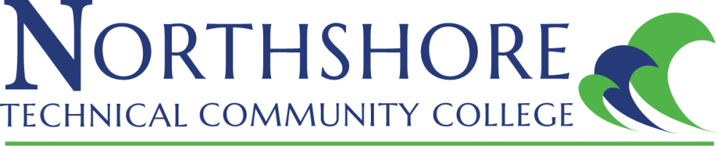

Faculty Senate 2022 – 2023
November 1, 2022 12:18pm -12:59pm
Virtual Meeting: Zoom
Attendance: Natasha Foret, Ollie Vignes, Sarah Alford, Angelina Carmichael, Said Raki, Michelle Burris, Arlendra Zenon, Kenneth Dunham, Tracie Bates, Rose Dedeaux, Carry Riche, Pamela Braden

- Meeting motioned to order at 12:18pm by Carry Riche, 2nd by Tracie Bates.
- Review of October Meeting Minutes
  - 1st motion to approve minutes as written by Angelina Carmichael, 2nd by Carry Riche.
- Old Business
  - Updates on adjunct pay rates – Natasha will provide update once she receives them.
- New Business
  - Welcome new senators!
    - Natasha Foret introduced and welcomed new senators.
      - Rose Dedeaux
      - Robert Pate
      - Tracie Bates
      - Regina Archote
      - Kenneth Dunham
  - Changes to the LCTCS Teaching Faculty Evaluation Tool- Natasha Foret provided an overview.
    - Faculty feedback will be submitted in writing via email response toFaculty Senate. Natasha Foret will send out an email for feedback after the November meeting concludes. A follow-up meeting to discuss feedback is available upon request.
- Updates: Faculty Senate Sub-Committees
  - Faculty Affairs – Sarah Alford provided update: Topic Enrollment lock date: Meeting with Registar, Human Resources and Financial Aid this week.
  - Finance Committee - Angelina Carmichael provided update: Reached out to Financial Affairs Department to find out information on steps regarding moving the Faculty Senate account. Awaiting information.
  - Public Relations – Pamela Braden provided update: The website is currently being updated with the Faculty Senate Updated Handbook and new members information. Gator Good News: Suggestions on what to submit were provided. Natasha Foret suggested our first submission be a “Meet Your Faculty Senate Spotlight.” It was agreed.
  - Faculty On-boarding: No update at this time.
- Discussion
  - Open floor for new discussions
  - Reminders provided by Natasha Foret.
    - Upcoming Professional Development Opportunities
      - Faculty Brown Bag Lunch series
        - November 2, 2022: “Alternative Assessments”
      - Online Learning trainings
        - Refer to email from Department of Online Learning about upcoming trainings available in Fall 2022.

- Closing
  - Next meeting to be determined.
  - Motion to adjourn meeting by Sarah Alford, 2nd by Kenneth Dunham. Meeting adjourned at 12:59pm.

