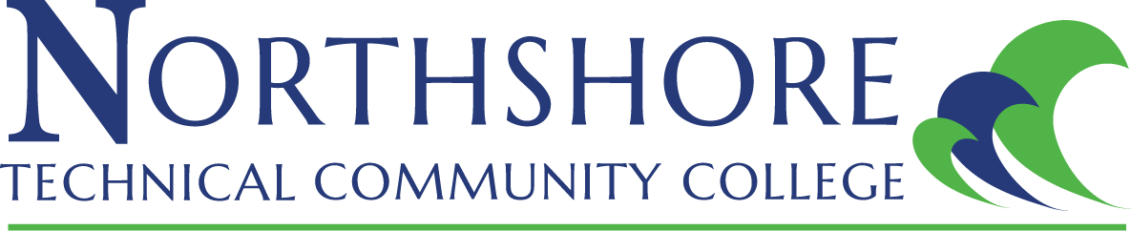

Master Syllabus

COURSE: DPET 2999 practicum

crn NUMBER:

CREDIT HOURS (Lecture/Lab/Total): 0/3/3

CONTACT HOURS (Lecture/Lab/Total): 0/135/135

INSTRUCTOR INFORMATION:
Name:
Email:
Office:
Office Hours:
Class Location:

COURSE DESCRIPTION: Students receive the opportunity to exercise, as well as, apply the skills mastered while participating in live work.

PREREQUISITES: Approval of Associate Provost of Technical Studies

LEARNING OUTCOMES: Upon completion of the course, the student will be able to:

ASSESSMENT MEASURES:

REQUIRED TEXTBOOKS:

SUPPLIES AND EQUIPMENT:

ATTENDANCE POLICY: It is the student’s responsibility to maintain regular contact with instructors. Class attendance is the responsibility of the student. All students must be officially enrolled in any course that they attend. It is expected that students attend all classes and be on time. If an absence occurs, it is the responsibility of the student for making up examinations, obtaining lecture notes, and otherwise compensating for what may have been missed. Students who stop attending class and do not officially drop, withdraw, or resign from the college may receive a grade of “F” for all coursework missed. Absences affect performance in this course and do not reflect well on participation. No student may substitute the attendance of another student. Online students must be actively participating in online courses to be considered making progress. Hybrid students must attend face-to-face meetings as well as complete online assignments.

Students should frequently check Canvas (Learning Management System) for notifications and updates to the course. Students are expected to use the online resources provided by NTCC to:
1. Track course assignments and progress
2. Discuss topics and issues with fellow students
3. Turn in assignments, quizzes, and tests
4. Check for any updates, changes or alterations to the course
5. Access all course materials to include presentations, assignments, quizzes, and tests.

GRADING REQUIREMENTS:

GRADING SCALE:
A 90-100%
B 80-89%
C 70-79%
D 60-69%
F 59% below

ACADEMIC INTEGRITY AND CONDUCT: Students are expected to maintain the highest standards of academic integrity. Behavior that violates these standards is not acceptable. Plagiarism, cheating, and other forms of academic dishonesty are prohibited and are subject to disciplinary actions established in the Student Code of Conduct. The instructor reserves the right to assign a grade of “F” on any type of assignment or examination based on evidence that the student has violated the Student Code of Conduct.

STUDENT BEHAVIOR/CLASSROOM DECORUM: Students are encouraged to discuss, inquire, and express their thoughts and views during class. Classroom behavior that interferes with either the instructor’s ability to conduct the class or the ability of students to benefit from the instruction is not acceptable. Students are required to turn off all cell phones or similar electronic devices (or place them on silent mode) before coming into the classroom. The instructor reserves the right to assign no credit for work on that day if a student talks or texts on a cell phone or similar electronic device. The classroom is not a place for children, and students are not to bring their family members into the classroom.

DISABILITY CODE: If you are a qualified student with a disability seeking accommodations under the Americans with Disabilities Act, you are required to self-identify with the Student Affairs. No accommodations are granted without documentation authorized from Student Affairs.

WITHDRAWAL POLICY: The last day to withdraw from a course or resign from the college is _____________. If you intend to withdraw from the course or resign from the college, you must initiate the action by logging into LoLA. The instructor will not withdraw you automatically.

COMMUNICATION POLICY: My.NorthshoreCollege.Edu is the official student email communication within Northshore Technical Community College. Therefore, the College has the right to send communications to students via their College email address and the right to expect that those communications will be received and read in a timely fashion. Every student is assigned a My.NorthshoreCollege.Edu. Students can redirect their College email address to an outside email provider. However, the College is not responsible for handling outside email providers, and redirecting their College email address does not absolve a student from their responsibilities associated with communication sent to their official College email address.

COPYRIGHT POLICY: Unless a student has obtained permission from the copyright holder, it is a violation of Copyright Law to print or photocopy chapters from a textbook that the student did not purchase. If the course requires the use of an electronic textbook, a student must look for a statement that allows for photocopying and/or printing of the eTextbook.

NETIQUETTE POLICY: This term is used to describe accepted, proper behavior on the Internet. Remember the following when communicating online (messages, discussion board, etc.):
- Never post profanity, racist, or sexist messages
- Be respectful of fellow students and instructors
- Never insult any person or their message content
- Never plagiarize or publish intellectual property
- Do not use text messaging abbreviations or slang
- Do not type in all CAPS (this is considered online yelling)
PROGRAM DRESS CODE: Your appearance in the program must model industry expectations on a daily basis. The entire dress code will be covered during safety training.

